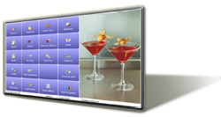
Simplicity for All Restaurants and Bars
Restaurant and bar operators are faced with complex and mission critical responsibilities such as point of sale, payment processing, inventory control, financial accountability, customer tracking, labor management, kitchen productivity, and much more everyday.
In the busy quest for success, time becomes a valuable commodity among restaurant operators. The ability to simplify and streamline operations not only helps increase the bottom line, but also yields the greatly desired leisure time for family and friends.
Aldelo For Restaurants Pro is the ideal point of sale and store management solution to help simplify operations for all table service restaurants, quick service restaurants and bars.
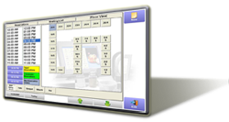
Increase Efficiency and Reduce Complexity
Aldelo For Restaurants Pro point of sale and management solution empowers restauranteurs increase efficiency and reduce complexity. It is a super simple to use, feature rich and cost effective solution without the need for prior computer experience.
Aldelo For Restaurants Pro takes care of point of sale activities, reservation and waiting list, guest and manager paging, customer tracking, gift card management, house account charges, delivery order routing and tracking, table service and quick service order entry, cashier payment handling, financial accountability, staff communications, and much more all included and ready for action out of the box.
Aldelo For Restaurants Pro gives restaurateurs complete management control at their fingertip. Management features such as inventory and recipe tracking; labor and scheduling control; extensive reports; and much more are all standard features and easily accessible with just a click away. Restaurateurs also gain insight into store operations effortlessly with dozens of extensive reports.
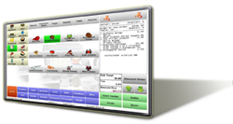
Maximize Productivity and ROI
Aldelo For Restaurants Pro is great for small, medium, and large restaurants and bars. We service customers ranging from a single point of sale terminal to more than ten point of sale terminals within one location. Aldelo For Restaurants Pro is also great for customers having just one store location, or hundreds of store locations across the country.
Our advanced software solution maximizes productivity with its full featured capabilities and ease of use. Imagine, Customers stay more satisfied with faster order processing; staff activities are more streamlined; managers are more informed about store operations; waste and mistakes are greatly reduced. Everything works perfectly, efficient and simplified everyday.
Regardless of your food service operation theme, type or size, Aldelo For Restaurants Pro is the perfect hospitality point of sale and store management solution to help you achieve simplicity, productivity and efficiency. Our cost effective software solution truly enables all restaurateurs to enjoy the benefits of store automation while achieving the best possible return on investment.

